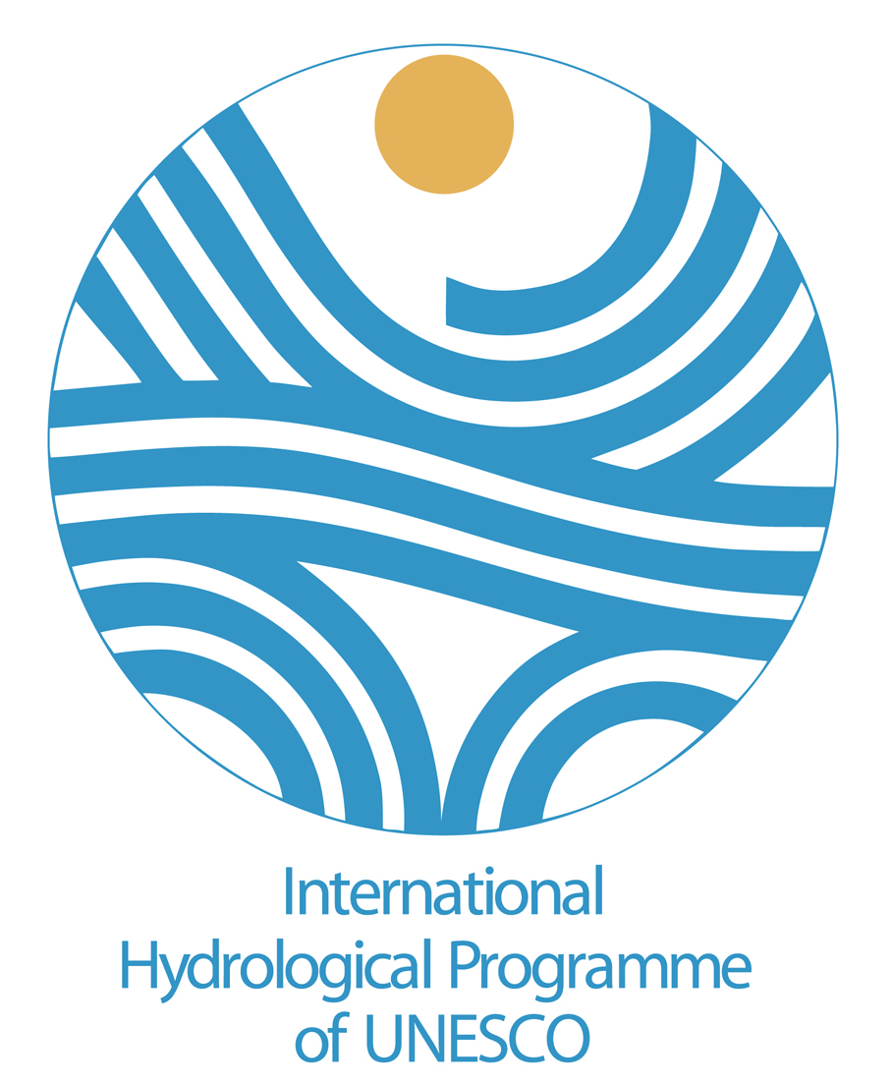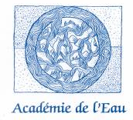

Provisional Agenda

Workshop on Transboundary aquifers

UNESCO Headquarters, 1 rue Miollis 75015 Paris, 29-30 May 2007

Background: the aim of this workshop is to underline the importance of transboundary aquifers across the world and to affirm the interdisciplinary nature of water management as well as the necessity to create a common language between the different disciplines.

Tuesday 29 May 2007

Room XVI

9h30 Opening of the meeting,
- Welcome address from the organizers

10h00
- UNESCO-IHP’s projects on Transboundary aquifers and the cooperation with the UN ILC Ms Raya Marina Stephan

10h20
- Conclusions of the Tournai colloquium on the management of transboundary aquifers, Académie de l’eau

10h40
- The draft articles on the law of transboundary aquifers, Ambassador Chusei Yamada

11h00
- Debate

11h30
- Coffee break

11h45
- Case study presentation, Mr Didier Pennequin

12h00
- Debate

12h30 Lunch break
(on your own, at UNESCO’s cafeteria)

14h15
- The EU Water Framework Directive, and the Groundwater Directive : focus on Transboundary aquifers, Mr Philippe Quevauviller

14h45
- The UNECE experience on transboundary aquifers, Mr John Chilton

15h15
- Debate

15h45
- Coffee break

16h00
- Groundwater in the mandate of the International Commission of the Escaut, Mr Arnould Lefebure

16h30
- Debate

18h00 Closing of the day

18h30 Cocktail convened by UNESCO-IHP

Wednesday 30 May 2007

Room XVI

09h30
- Transboundary aquifers in Hungary, Ms Eszter Havasné Szilágyi

09h50
- The carboniferous sandstone aquifer system between France, Flandres and Wallonia

10h10
- Debate

11h15
- Coffee break

11h30
- What next steps for the draft articles at the UN ILC, Ambassador Chusei Yamada

11h45
- General conclusions and wrap-up,

12h30 Closing of the meeting

