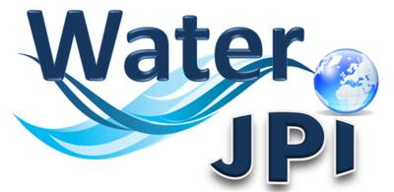 Press release
Joint Programming Initiative
Water challenges for a changing world

2016 WATER JPI CONFERENCE IN ROME ON 19 MAY 2016

The Water Joint Programming Initiative (JPI) will host its 2016 Conference in Rome on the 19th May 2016. This international event is targeted to a wide range of stakeholders and will present the new version of the Water JPI Strategic Research and Innovation Agenda (SRIA), and discuss on how to implement it and the benefits from international cooperation.

The WATER JPI SRIA version 2.0 lays out research, innovation and development needs in the water sector grouped by thematic areas and priorities selected after a stakeholders’ consultation for their scientific and societal importance and structured around these five core themes: Improving Ecosystem Sustainability and Human Well-being; Developing Safe Water Systems for the Citizens; Promoting Competitiveness in the Water Industry; Implementing a Water-Wise Bio-Based Economy; Closing the Water Cycle Gap Improving Sustainable Water Resources Management.

Following keynotes from the European Commission, and the Food and Agriculture Organization of the United Nations, round-table discussions will cover the identified water research priorities in the SRIA, its implementation, and the benefits of international cooperation to jointly tackle the grand challenge of achieving sustainable water systems in the world.

A poster session presenting the transnational projects funded to-date by the Water JPI will also take place during the conference.

To register for the conference, fill in this FORM.

More information on the Water JPI is available at www.waterjpi.eu

