4th AFUR ANNUAL CONFERENCE AND GENERAL ASSEMBLY

25-27 April 2007
Chrismar Hotel, Livingstone Zambia

A Re-Assessment of Regulatory Independence and Accountability:
How effective are Africa’s Infrastructure Regulators in Facilitating Investment and Protecting Consumers?

20th March 2007

Dear Participant,

INVITATION

You are cordially invited to attend the African Forum for Utility Regulators (AFUR)’s 4th Annual Conference and General Assembly to be hosted on 25 - 27 April, 2007 at the Chrismar Hotel in Livingstone, Zambia. The events will be hosted by the National Water and Sanitation Council (NWASCO), jointly with the Communications Authority of Zambia (CAZ) and the Energy Regulatory Board (ERB), all of Zambia.

The conference will be attended by over 150 delegates from around the world including utility regulators, senior government officials, and the private sector, suppliers of energy, communications, water and sanitation equipment, as well as representatives from international development and finance institutions, investors and utility service providers.

The 4th Annual Assembly will be preceded by a conference on the theme “A Re-Assessment of Regulatory Independence and Accountability: How Effective are Africa’s Infrastructure Regulators in Facilitating Investment and Protecting Consumers?”. The event offers a unique opportunity for regulators, investors and operators throughout Africa and around the world to engage on regulatory issues of common interest.

Kashone Communications based in Lusaka, Zambia have been appointed as the Event Management Company and apart from managing the logistics of the Conference, are readily available to provide delegates with the necessary information on travel to Zambia and the proceedings that will be taking place. Contact the Event Management Company: Kashone Communications on Tel: 00 260 (1) 256142/251132. Fax: 00 260 (1) 251132 or email: kashone@zamnet.zm

Should you require more detailed technical information on the conference, however, please feel free to contact us or the AFUR Secretariat care of:

Mr. Symerre Grey-Johnson Tel: + 27 12 401 4600 or email: symerregj@afurnet.org

We have no doubt that we would benefit from your participation at this conference and look forward to receiving your fully completed registration form (attached) by the 30th of March 2007. Kashone Communications will advise you accordingly on your reservation status.

May we take this opportunity to advise all our delegates, that each participant is responsible for his/her own travel costs, accommodation and non-conference meals. The draft programme will be made available to you within the next few weeks. You are also requested to consult the AFUR website (http://www.afurnet.org) for conference updates.

We look forward to hearing from you with a confirmation on your participation in this very important event.

Yours sincerely,
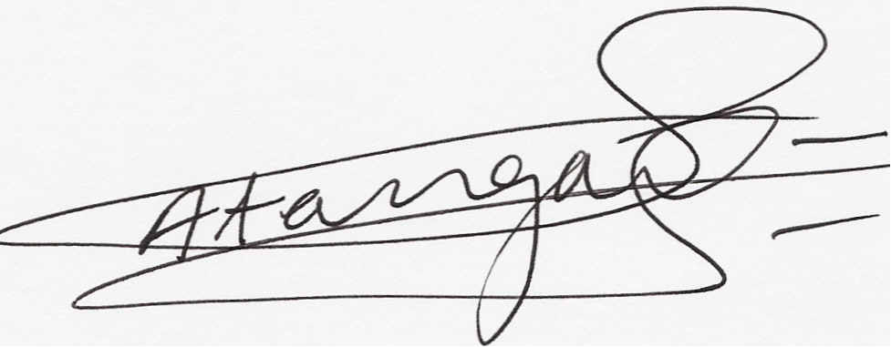

Mufor Atanga
Executive Secretary: AFUR

Attachments : Registration Form
General Information on Zambia

